Problem statement -
Microsoft Copilot is evolving toward more agentic capabilities, creating an opportunity to establish strong user adoption today while building habits and workflows that deliver long-term value. The challenge is to drive meaningful adoption of Copilot in a way that goes beyond short-term usage or experimentation and helps users progressively integrate Copilot into their everyday workflows, preparing them to benefit from its future agentic capabilities.
- Goals and What are my non-goals -
  - Goals
    - Increase the number of tasks successfully completed by Copilot across Microsoft applications.
    - Increase the task success rate for tasks requested through Copilot.
  - Non-goals
    - Introduce a new standalone application or destination for Copilot tasks.
    - Users should be able to complete supported tasks within their current Microsoft application without unnecessary screen or application switching.
    - Video creation workflows are out of scope for the initial phase.
2. Success metric
  - North Star - Increase Copilot commercial adoption and usage month over month.
  - L1 - Number of users who complete their first meaningful Copilot task. Average number of successfully completed Copilot tasks per active user.
  - Counter - Task drop-off rate — % of initiated Copilot tasks that users do not complete, D30 inactivation rate — % of users who adopt Copilot but become inactive within 30 days.
3. User Journey - Empathy Map
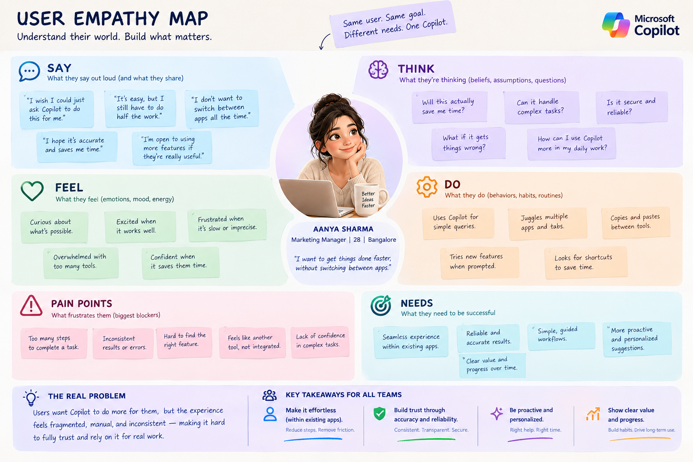
4. What is the competitor offering
End-to-End Intelligent Execution — Copilot understands the goal, coordinates the required steps, and completes the task across applications.
Connected Context & Multi-Agent Orchestration — Copilot uses context across applications and coordinates specialized agents to solve complex tasks.
Transparent & Controllable Execution — Copilot clearly shows what it is doing, why it is doing it, and gives users visibility and control throughout the process.

Opportunity | Reach | Impact | Confidence | Effort | Priority
End-to-End Intelligent Execution | MED | HIGH | MED | MED | P0
Connected Context & Multi-Agent Orchestration | HIGH | HIGH | HIGH | MED | P1
Transparent & Controllable Execution | MED | MED | HIGH | HIGH | P2

5. FUNCTIONAL AND ACCEPTANCE CRITERIA / NON-FUCTIONAL REQUIREMENTS
- Functionals - User prompts given either via typed text or voice should be picked as an individual executable with limited handholding from the end user. It should complete all the tasks for the user and also save the output pattern as a docx, canva, email or other connector tools. It should then using agents work in a repeatable fashion.
- Non-functional requirement -
  - P - performance - output generation should be completed within 45 seconds
  - Q - Quality - the response should be within 5000-8000 tokens unless specified by the user
  - R - Reliability - the user should be able to recover, restore and re-trigger the chats without losing context
  - S - ˘Secure - the user data should be end to end encrypted and only stored on user device. Data leaves the local system only when explicitly user requests for a backup.
  - T - Transparency - All executions should have a clear recoverable log and chain of thought for the user
  - U - Useability - All actions should complete within 3-4 prompt interactions.

6. MOCK-UP - tool link - https://stitch.withgoogle.com/
7. PROTOTYPES (TENTATIVE)
8. GITHUB PUSH AS A PORTOLIO

